**Bildr**

This is a how-to guide on the use of the 3D development tool that creates prefabs at a set size which helps create houses/buildings which can be edited and used within your game. Another great use for this tool is to use it as placement holders to develop environments in order for them to be replaced at a later date with other assets/architecture (Greyboxing).

**Step 1**

Along the Unity bar click the Bildr menu button.

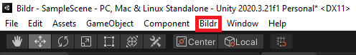

**Step 2**

Within the submenu click create.

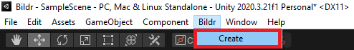

**Step 3**

Within the window you now have a selection of named buttons that now can be pressed which will create the required prefab. There is also an option for a random generator which will be explained further on within this manual.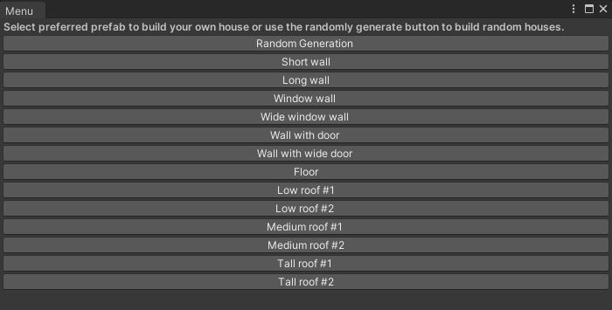

**Step 4**

Upon clicking one of these buttons (for example the window wall button) the prefab is placed within the scene.

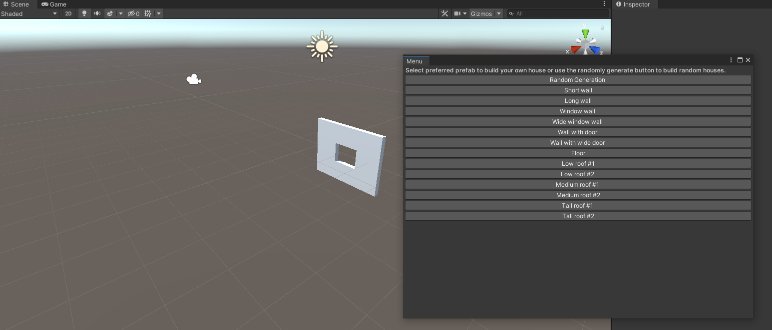

**Random Generator Button**

Upon clicking this button a random generated house is created which can then be moved to the required location. These houses use the for loop sequence with parent and child objects.